Climbing Escher’s stairs, or how to estimate stability landscapes for multidimensional deterministic systems

Pablo Rodríguez-Sánchez, Egbert van Nes & Marten Scheffer

2019-03-04

Stability landscapes are useful tools for understanding dynamical systems. These landscapes are usually calculated from differential equations in analogy with the physical concept of potential. Unfortunately, the conditions for those potentials to exist are quite restrictive for systems with two or more state variables. Here we present a numerical method for decomposing differential equations of any size in two terms, one that has an associated potential (the gradient term), and another one that lacks it (the curl term). In regions of the state space where the magnitude of the curl term is small compared to the gradient part, we can still make approximate use of the concept of potential. The curl to gradient ratio can be used to estimate the local error introduced by our approximation. Both the algorithm and a ready-to-use implementation in the form of an R package are provided.

# Introduction

With knowledge becoming progressively more interdisciplinary, the relevance of science communication is increasing fast. Mathematical concepts are among the hardest topics to communicate to non-expert audiences, policy makers, and also to scientists with little mathematical background. Visual methods are known to be successful ways of explaining mathematical concepts and results to non-specialists.

One particularly successful visualization method is that of the stability landscape, also known as the rolling marble or ball-in-a-cup diagram (Beisner, Haydon, and Cuddington (2003), Edelstein-Keshet (2005), Strogatz (1994)), whose origins can be traced back to the introduction of the scalar potential by Lagrange in the XVIII century (Lagrange (1777)). In stability landscapes (e.g.: figure 1) the position of the marble represents the state of the system at a given time. With this picture in mind, the shape of the surface represents the underlying dynamical rules, where the slope is the driver of the movement. The peaks on the undulated surface represent unstable equilibrium states and the wells represent stable equilibria. Different basins of attraction are separated by *mountain ridges* in the surface. Summarizing: the marble naturally rolls downhill to the lowest point of its basin of attraction.

The main reason for the success of this picture arises from the fact that stability landscapes are built as an analogy with our most familiar dynamical system: movement. Particularly, the movement of a marble along a curved landscape under the influence of its own weight and a strong frictional force. The stability landscape corresponds then with the physical concept of potential energy (Strogatz (1994)). This explains why our intuition, based in what we know about movement in our everyday life, works so well reading this diagrams. It is important to stress the fact that under this picture there’s not such a thing as inertia (Beisner, Haydon, and Cuddington (2003)). The accurate analogy is that of a marble rolling in a surface while submerged inside a very viscous fluid (Strogatz (1994)).

Stability landscapes have proven to be a successful tool to explain advanced concepts related with the stability of dynamical systems in an intuitive way. Some examples of those advanced concepts are multistability, basin of attraction, bifurcation points and hystheresis (see Scheffer et al. (2001), Beisner, Haydon, and Cuddington (2003) and figure 1).

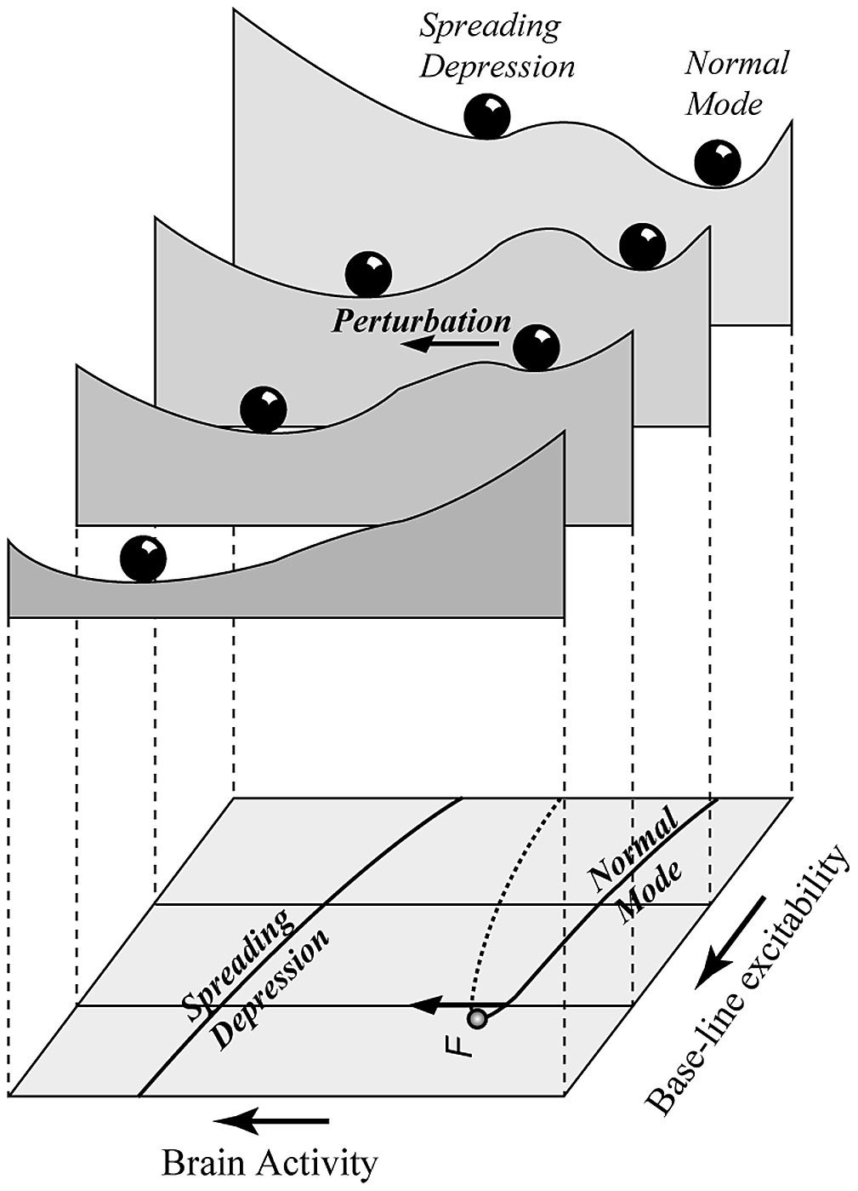

Figure 1 Example of a set of 4 stability landscapes from Scheffer et al. (2001). The upper side of the figure shows the stability landscape of a one-dimensional system for 4 different values of a control parameter. The lower side shows the bifurcation diagram. This diagram proved to be a succesful tool for explaining advanced concepts in bifurcation theory such as bistability and fold bifurcations.

Like with any other analogy, it is important to be aware of its limitations. The one we address here is the fact that, for models with more than one state variable, such a potential doesn’t exist in general. To get an intutive feeling of why this is true, picture a model with a stable cyclic attractor. As the slope of the potential should reflect the speed of change, we would need a potential landscape where our marble can roll in a closed loop while always going downhill. Such a surface is a classical example of an impossible object (see figure 2 and L. S. Penrose and Penrose (1958) for details).

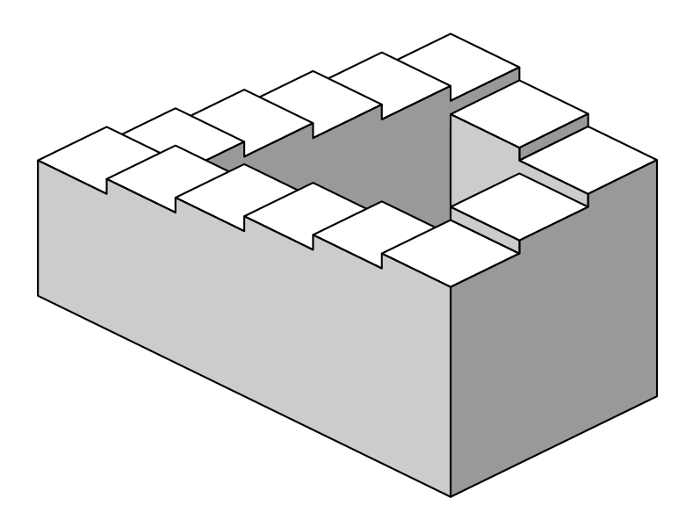

Figure 2 The Penrose stair (L. S. Penrose and Penrose (1958)) is a classical example of an impossible object. In such a surface, it is possible to walk in a closed loop while permanently going downhill. This object was popularized by the Dutch artist M.C. Escher (for a beautiful example, see Escher (1960). The same idea is explored in Escher (1961)).

Being this a centuries-old problem (see for instance Helmholtz (1858)), several methods have been proposed to estimate stability landscapes for general, high-dimensional systems. A comprehensive review can be found in Zhou et al. (2012). Nevertheless, we share the perception with other authors (Beisner, Haydon, and Cuddington (2003)) that the concept of potential is often misunderstood in research communities with a limited mathematical background, and that even methods like the ones described in Zhou et al. (2012) are often, and perhaps unfairly discarded as “too complicated to implement”.

Here we review the state of the art, and present a new method to deal with the fundamental problem of approximating stability landscapes for high dimensional systems. First, we present an overview of the conditions that a model has to fulfill to be robustly associated with a potential. Next, we center our attention in systems that fail to fulfill those conditions, and we introduce an algorithm to decompose them as the sum of a gradient and a non-gradient part. Each part can be used, respectivelly, to compute an associated potential and to measure the local error introduced by our picture. In order to reach those interested readers with little background in mathematics, we limited our mathematical weaponry. Knowledge of basic linear algebra and basic vector calculus will suffice to understand the paper to its last detail. Additionally, we provide a ready to use *R* package that implements the algorithm this paper describes.

## Mathematical background

Consider a coupled differential equation with two state variables and . The dynamics of such system can be described by a two-dimensional stability landscape if a potential function exists whose slope is proportional to the change in time of both states (equation (1)).

Such a potential exists if and only if the crossed derivatives of functions and are equal for all and (equation (2)). Vector fields satisfying equation (2) are known as conservative, irrotational or gradient fields (cf. section 8.3 of Marsden and Tromba (2003)).

If condition (2) holds, we can use a line integral (Marsden and Tromba (2003), section 7.2) to invert (1) and calculate using the functions and as an input. An example of this inversion is equation (3), where we have chosen an integration path composed of a horizontal and a vertical line. The attentive reader may have raised her or his eyebrow after reading the word *chosen* applied to an algorithm. In fact, we can introduce this arbitrary choice without affecting the final result. The condition for potentials to exist (equation (2)) is entirelly equivalent (cf. section 7.2 of Marsden and Tromba (2003)) to the path independence of any line integral between two points inside this vector field. If the condition was not fulfilled, the calculated potential will have depended crucially on the chosen integration path. Being an arbitrary choice, the computed potential will have been an artifact with no natural meaning.

Those readers interested in systems with 3 or more state variables can find a generalization of these results in section 5.1 of the online appendix.

# Methods

The method for deriving a potential we propose is based on the decomposition of a vector field in a conservative or gradient part and a non-conservative or curl part (see equation (4)).

captures the part of the system that can be associated to a potential function, while represents the deviation from this ideal case. We’ll use to compute an approximate potential. The absolute error of this approach will be given by the euclidean size of the curl term . In those regions where the gradient term is stronger than the curl term, the condition (2) will be approximately fulfilled, and thus the previously calculated potential will represent an acceptable approximation of the underlying dynamics. If not, the curl term is too dominant to construct a potential landscape. The next steps show an easy way of achieving such a decomposition.

For this we have first to linearize the model. Any sufficiently smooth and continuous vector field can be approximated around a point using equation (5), where is the jacobian matrix evaluated at the point and is defined as the distance to this point, that is, , written as a column vector.

As usual in linearization, we have neglected the terms of order and higher in equation (5). This approximation is valid for close to . For an equation like (5), the condition on the crossed derivatives (for 2 dimensions, equation (2), for any dimensions, equation (16) in online appendix) becomes a very simple restriction on the jacobian matrix: for the system to be gradient, its jacobian has to be symmetric (see equation (6), where represents transposition).

We know from basic linear algebra that any square matrix can be uniquely decomposed as the sum of a skew and a symmetric matrix (see equation (7)).

Using the skew symmetric decomposition described in equation (7), we can rewrite (5) as:

Equation (8) represents a natural, well-defined and operational way of writing our vector field decomposed as in equation (4), that is, as the sum of a gradient and a non-gradient term[1] (see (9)).

The gradient term can thus be associated to a potential that can be computed analytically using a line integral (see equation (3) for the two dimensional case, or (18) in the online appendix for the general one). The result of this integration yields an analytical expression for the potential difference between the reference point and another point separated by a distance (see equation (10)).

Provided we know the value of the potential at one point , equation (10) allows us to estimate the potential at a different point (cf.: equation (11)).

Equation (11) can be applied sequentially over a grid of points to calculate the approximate potential on each of them. In two dimensions, the resulting potential is given by the closed formula (12). The cases with 3 and more dimensions can be generalized straightforwardly. For a step by step example, see section 5.2 in the online appendix. For a flowchart overview of the algorithm, please refer to section 5.3 in the online appendix:

As with any other approximation we need a way to estimate and control its error. The stability landscape described in (10) has two main sources of errors:

1. It has been derived from a linearized system
2. It completely neglects the effects of the curl part of the system

The error due to linearization is roughly proportional to in equation (10), being the euclidean distance to the reference point. By introducing a grid, we expect the linearization error to decrease with the grid’s step size.

The more fundamental error due to neglecting the curl component of our system is not affected by the grid’s step choice. From equation (4) it is apparent that we can use the euclidean size of as an approximation of the local error introduced by our algorithm. The relative error due to this effect can be estimated using equation (13).

## Code package

As an application of the abovementioned ideas, and following the spirit of reproducible research, we developed transparent *R* package we called *consRvative*. Our algorithm accepts a set of dynamical equations and a grid of points defining our region of interest as an input. The output is the estimated potential and the estimated error, both of them calculated at each point of our grid (see figure 3).

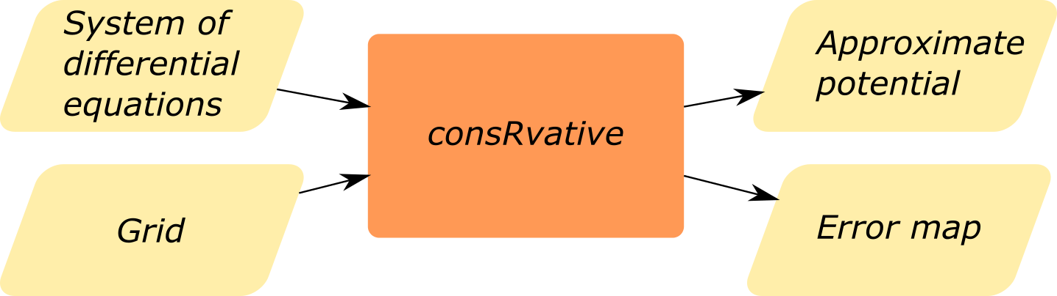

Figure 3 Flowchart showing the basic usage of consRvative. Those readers interested in a more detailed overview of the algorithm can refer to figure 7 in the online appendix.

The package is tested, documented and freely available at <https://github.com/PabRod/consRvative>. It can also be installed via *devtools* by typing devtools::install_github("PabRod/consRvative", ref = "develop") in the *R* console.

# Results

## A synthetic example

We first tested our algorithm with a synthetic model of two uncoupled state variables each with two attractors. As both states are uncoupled, this system is gradient and has a potential with four wells. We added interaction terms and to be able to make it gradually non-gradient (see equation (14) and figure 4). When we chose those non-gradient interactions to be zero, the system becomes gradient and corresponds with a four-well potential. Our algorithm rendered it succesfully (cf. figure 4, left panel).

After introducing non-gradient interactions a four-well potential is still recognizable (figure 4, central panel). The error obtained correlates with the two perpendicular stripes of the plane were we defined the non-gradient interactions to be maximum (figure 4, right panel).

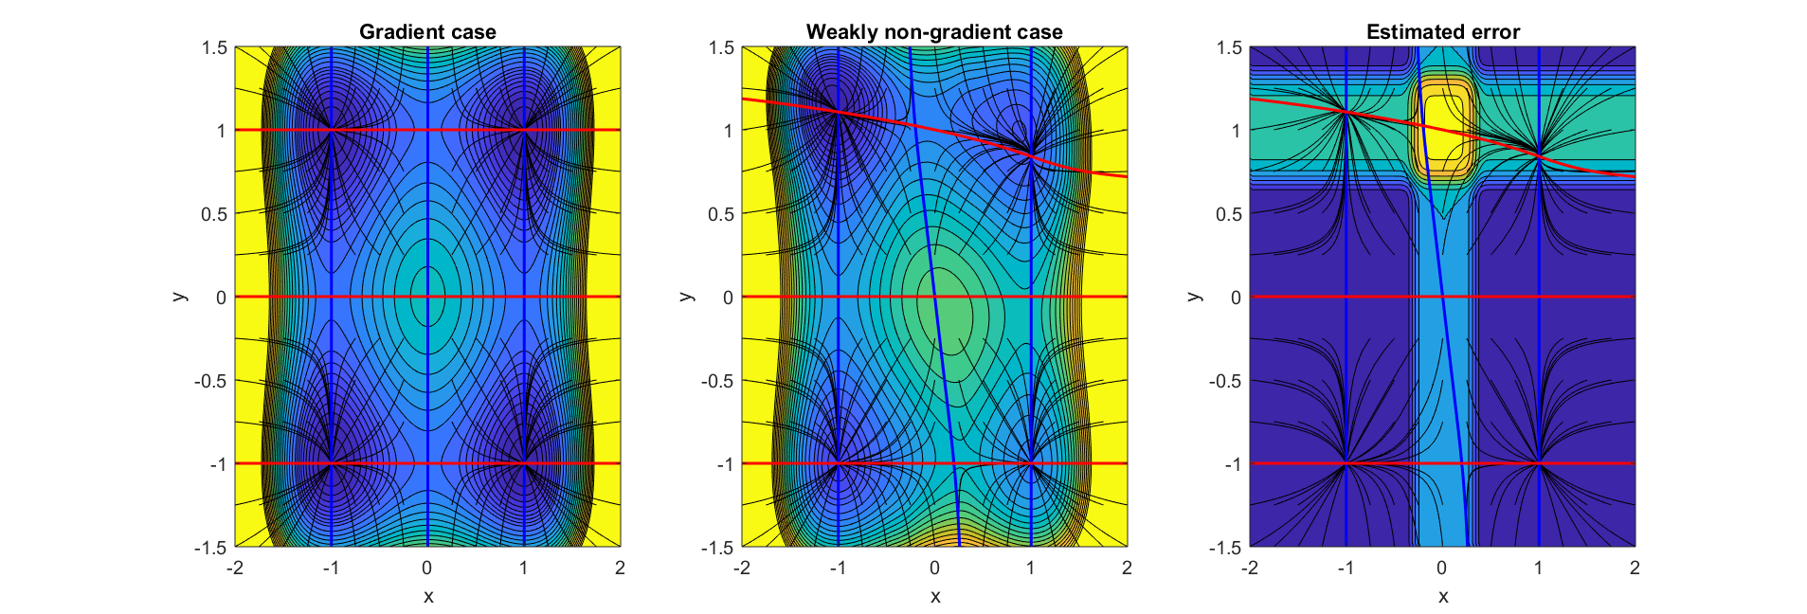

Figure 4 In all three figures the red and blue lines represent the nullclines of and , respectivelly. Several trajectories are plotted in black. The contour plot in figure a) shows the potential calculated for the gradient case (i.e.: ). As expected, the stable equilibria correspond to the wells. The contour plot in figure b) also shows the potential, but now we made and in order to introduce a-non gradient interaction term. Defined this way, the non-gradient term will be significantly distinct from zero around the bands centered at and . It can be noticed that the shape of the potential has been distorted. Notice also that the two equilibria at the upper side of the plot fall slightly outside their closest well. The equilibria at the bottom, to the contrary, fit perfectly centered in their corresponding wells. Figure c) shows the estimated error of our computed potential. As expected, the error is zero everywhere but in the bands centered around and . This figure warns us against trusting the potential we obtained in the upper and central region, and guarantees us that elsewhere it will work fine. Notice that the two upper equilibria lie in a region where the error is clearly not negligible. The two lower ones, on the contrary, lie on a region where the error is almost zero, so we can safely use the previously derived potential to visualize them. This goes in accordance with our previous observation about the slight mismatch between equilibria and potential wells in the upper part of the figure.

## A biological example

### A simple regulatory gene network

Waddington’s epigenetic landscapes (Gilbert (1991)) are a particular application of stability landscapes to gene regulatory networks controlling cellular differentiation. When applied to this problem, stability/epigenetic landscapes serve as a visual metaphor for the branching pathways of cell fate determination (Bhattacharya, Zhang, and Andersen (2011)).

A bistable network cell fate model can be described by a set of equations like (15). Such a system represents two genes ( and ) that inhibit each other. This circuit works as a toggle switch with two stable steady states, one with dominant , the other with dominant (see Bhattacharya, Zhang, and Andersen (2011)).

The parameters used are identical to those in equations 6 and 7 of Bhattacharya, Zhang, and Andersen (2011), with the exception of and , that we modified in order to induce an assymetry in the the dynamics (we used and ).

Despite the fact that this system is clearly non-gradient, our algorithm correctly predicts the existence of two wells (see figure 5).

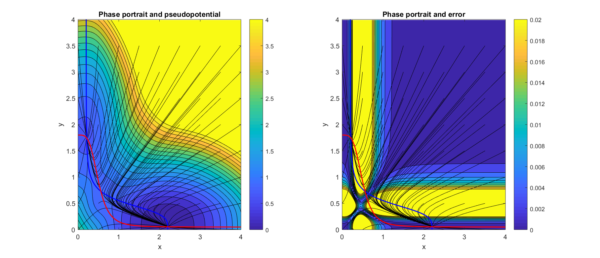

Figure 5 In both figures the red and blue lines represent the nullclines of and , respectivelly. Several trajectories are plotted in black. The contour plot in figure a) shows the potential calculated for the simple gene regulatory network described in equation (15). The stable equilibria correspond to the wells. Figure b) shows the estimated error of our computed potential.

# Discussion

The use of stability landscapes as a helping tool to understand one-dimensional dynamical systems achieved great success, specially in interdisciplinary research communities. A generalization of the idea of scalar potential to two-dimensional systems seemed to be a logical next step. Unfortunately, as we have seen, there are reasons that make two (and higher) dimensional systems fundamentally different from the one-dimensional case. The generalization, straightforward as it may look, is actually impossible for most dynamical equations. As a consequence, any attempt of computing stability landscapes for high-dimensional systems should, neccessarily, drop some desirable properties of classical scalar potentials.

For instance, the method proposed by Bhattacharya, Zhang, and Andersen (2011) smartly avoids the problem of path dependence of line integrals by integrating along trajectories, removing thus the freedom of path choice. The price paid is that this algorithm cannot guarantee simultaneous continuity at all equilibria and along separatrices for general systems.

A more theoretical review of pseudopotential computation, for a mathematically oriented audience, can be found in Zhou et al. (2012). Here, different criterions are used to decompose the dynamics in a scalar potential and an extra term. Unfortunately, our experience is that those methods, despite their obvious quality, have a limited impact outside the physicist community due to their mathematical complexity.

The algorithm we present here is an attempt to preserve as much as possible from the classical potential theory while keeping the mathematical complexity as low as possible. Indeed, it calculates the closest classical potential to our problem (and thus the exact one in case it exists). The price we pay is to calculate a potential that, in general, is only locally meaningful. The estimated error lets us know where this does happen. Additionaly, our algorithm provides:

* Simplicity. The required mathematical background is covered by any introductory course in linear algebra and vector calculus.
* Usability. We provide the algorithm in the form of a ready to use, documented and tested *R* package.
* Integrity. At each step the strength of the curl term is calculated. If this term is high, it is fundamentally impossible to calculate a scalar potential with any method. The relative size of the curl term can be interpreted as an error term, mapping which regions of our stability landscape are dangerous to visit.
* Speed. The rendering of a printing quality surface can be performed in no more than a few minutes in a personal laptop.

The concept of potential is paramount in physical sciences, where its use goes way further than visualization. The main reason for the ubiquity of potentials in physics is that several physical systems are known to be governed only by gradient terms (e.g.: movement in conservative systems, classical gravitatory fields, electrostatic fields, …). Physical potentials can be related with measurable concepts like energy. From the depth and width of a potential we can learn about transition rates and resilience to pulse perturbations. The height of the lowest barrier determines the minimum energy to transition to an alternative stable state, which relates to the probability of a critical transition via the Arrhenius equation (Hänggi, Talkner, and Borkovec (1990)). All these results from physics remain true for non-physical problems that happen to be governed exclusively by gradient dynamics, and, we claim, should remain approximately true for problems governed by weakly non-gradient dynamics. This is the situation our algorithm has been designed to deal with.

Regarding visualization alone, it may be worth reconsidering why do we prefer the idea of stability landscape over a traditional phase plane figure, specially after pointing out all the difficulties of calculating stability landscapes for higher-dimensional systems. It is true that the latter is slightly less intuitive than the stability landscape, but it has a very desirable property: it always exists.

# Acknowledgments

This work was greatly inspired by the dicussions with Cristina Sargent, Iñaki Úcar, Enrique Benito, Tobias Oertel-Jäger, Jelle Lever, and Els Weinans. This work was supported by funding from the European Union’s *Horizon 2020* research and innovation programme for the *ITN CRITICS* under Grant Agreement Number *643073*.

# Online appendix

## Gradient conditions for a system with an arbitrary number of dimensions

Dynamics in equation (1) and the condition for the crossed derivatives (2) can be straightforwardly generalized (see equations (17) and (16) to systems with an arbitrary number of state variables . Particularly, if and only if our system of equations satisfies the condition:

then exists a potential , related to the original vector field by:

and such a potential can be computed using a line integral:

where the line integral in (18) is computed along any curve joining the points and .

It is important to note that the number of equations () contained in condition (16) grows with the dimensionality of the system (), particularly following the series of triangular numbers . Thus, the higher the dimensionality, the harder it gets to fulfill condition (16). As a side effect, we see that one-dimensional systems always have a well defined stability landscape.

## Detailed example of application

For instance, to calculate the value of at the point of a grid, we should begin by assigning to the potential at our arbitrary starting point (i.e.: by definition). Then, we need a trajectory that goes from to , iterating over the intermediate grid points (see figure 6).

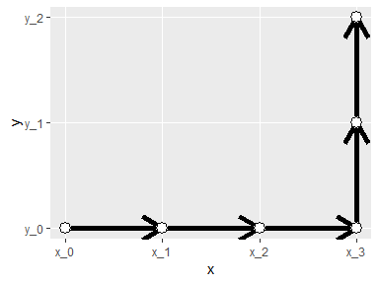

Figure 6 Path used to go from point to . Note that this is not the only possible path. Our algorithm converges to the same potential regardless of the path chosen thanks to neglecting the skew part of the jacobian in our linearization process.

In the first step we go from to . The new potential is thus (using (11)):

The next two steps continue in the horizontal direction, all the way to . The value of the potential there is:

Now, to reach our destination we have to move two steps in the vertical direction:

Generalizing the previous example we see that we can compute the approximate potential at a generic point using the closed formula (12). Both our example (21) and formula (12) have been derived sweeping first in the horizontal direction and next in the vertical one. Of course, we can choose different paths of summation. Nevertheless, because we are building our potential neglecting the curl part of our vector field, we know that our results will converge to the same solution regardless of the chosen path.

## Detailed flowchart

Those readers interested in the details of our algorithm may find figure 7 illuminating:

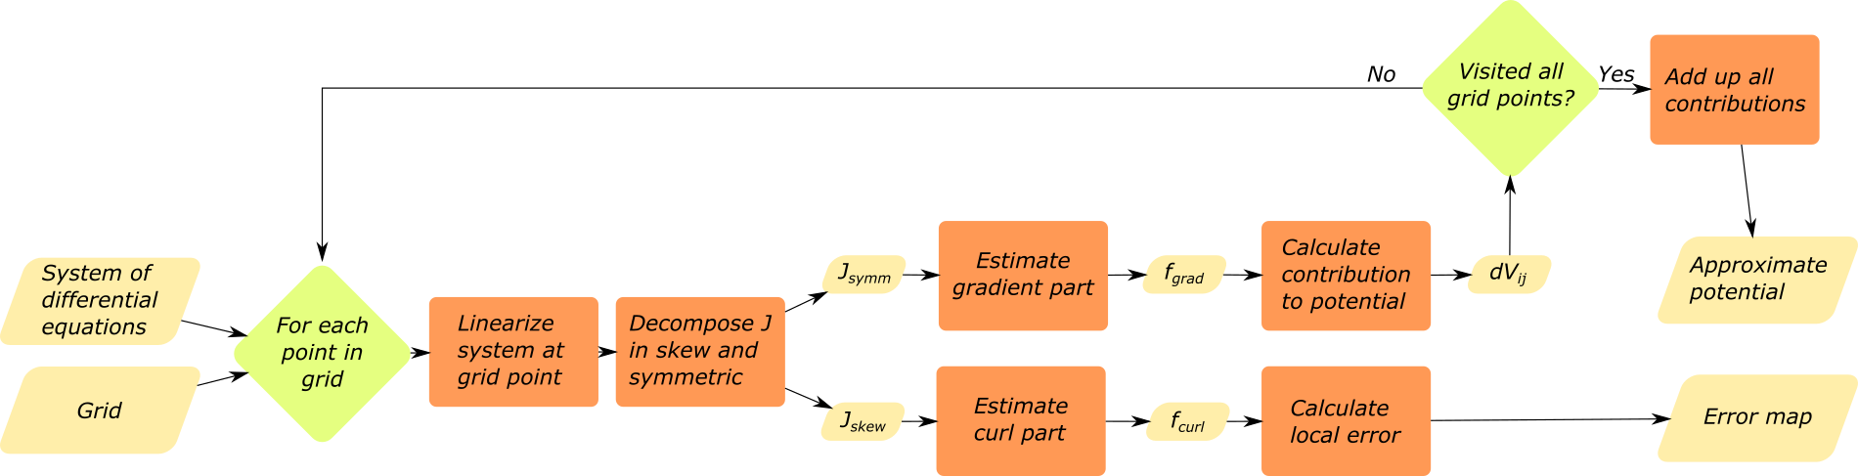

Figure 7 Detailed flowchart of our algorithm

## Notes and loose thoughts

### Glossary

I am using as almost synonyms the terms:

* Potential (also classical potential and scalar potential)
* Stability landscape
* Surface

### Why the existence of a potential fails for more than 1 dimension? Alternative approaches

#### From mechanics

The perpetual oscillation of a rolling marble while submerged in a very viscous fluid is impossible. This rules out the existence of potentials for systems with cyclic attractors.

Perpetual oscillation is known to be only possible in systems with two or more dimensions (by virtue of the Poincaré-Bendixson theorem (Strogatz (1994))).

#### From information theory

If we want to summarize, for instance, a two-dimensional system in a single surface, the height at each point of such a surface should contain the information about the derivatives of both states. That is, one number, height, codes two numbers. The process of computing the surface is a process of information compression, and it is known from mathematics that only gradient fields allow this kind of compression. In one-dimensional systems there is no compression of information (one number, height, corresponds to one number, the derivative of the only state), so this restriction does not apply in the one-dimensional case.

# References

Beisner, BE, DT Haydon, and K. Cuddington. 2003. “Alternative stable states in ecology.” *Frontiers in Ecology and the Environment* 1 (7). John Wiley & Sons, Ltd: 376–82. doi:[10.1890/1540-9295(2003)001[0376:ASSIE]2.0.CO;2](https://doi.org/10.1890/1540-9295(2003)001%5b0376:ASSIE%5d2.0.CO;2).

Bhattacharya, Sudin, Qiang Zhang, and Melvin E Andersen. 2011. “A deterministic map of Waddington’s epigenetic landscape for cell fate specification.” *BMC Systems Biology* 5 (1): 85. doi:[10.1186/1752-0509-5-85](https://doi.org/10.1186/1752-0509-5-85).

Edelstein-Keshet, Leah. 2005. *Mathematical Models in Biology*. Society for Industrial; Applied Mathematics. doi:[10.1137/1.9780898719147](https://doi.org/10.1137/1.9780898719147).

Escher, Maurits Cornelis. 1960. “Klimmen en dalen.”

———. 1961. “Waterval.”

Gilbert, Scott F. 1991. “Epigenetic landscaping: Waddington’s use of cell fate bifurcation diagrams.” *Biology & Philosophy* 6 (2). Kluwer Academic Publishers: 135–54. doi:[10.1007/BF02426835](https://doi.org/10.1007/BF02426835).

Hänggi, Peter, Peter Talkner, and Michal Borkovec. 1990. “Reaction-rate theory: fifty years after Kramers.” *Reviews of Modern Physics* 62 (2). American Physical Society: 251–341. doi:[10.1103/RevModPhys.62.251](https://doi.org/10.1103/RevModPhys.62.251).

Helmholtz, Hermann von. 1858. “Über Integrale der hydrodynamischen Gleichungen, welcher der Wirbelbewegungen entsprechen.” *Journal Für Die Reine Und Angewandte Mathematik* 55: 25–55. [https://books.google.com/books?id=6gwPAAAAIAAJ{\&}pg=PA25{\#}v=onepage{\&}q{\&}f=false](https://books.google.com/books?id=6gwPAAAAIAAJ%7b\&%7dpg=PA25%7b\#}v=onepage{\&}q{\&}f=false).

Lagrange, Joseph-Louis. 1777. “Remarques générales sur le mouvement de plusieurs corps qui s’attirent mutuellement enraison inverse des carrés des distances.” Académie royale des Sciences et Belles-Lettres de Berlin. [https://archive.org/stream/oeuvresdelagrang04lagr{\#}page/396/mode/2up](https://archive.org/stream/oeuvresdelagrang04lagr%7b\#}page/396/mode/2up).

Marsden, Jerrold E., and Anthony Tromba. 2003. *Vector calculus*. W.H. Freeman.

Penrose, L. S., and R. Penrose. 1958. “Impossible objects: A special type of visual illusion.” *British Journal of Psychology* 49 (1). John Wiley & Sons, Ltd (10.1111): 31–33. doi:[10.1111/j.2044-8295.1958.tb00634.x](https://doi.org/10.1111/j.2044-8295.1958.tb00634.x).

Scheffer, Marten, Steve Carpenter, Jonathan a Foley, Carl Folke, and Brian Walker. 2001. “Catastrophic shifts in ecosystems.” *Nature* 413 (6856): 591–96. doi:[10.1038/35098000](https://doi.org/10.1038/35098000).

Strogatz, Steven H. 1994. *Nonlinear Dynamics and Chaos: With Applications to Physics, Biology, Chemistry and Engineering*.

Zhou, Joseph Xu, M. D. S. Aliyu, Erik Aurell, and Sui Huang. 2012. “Quasi-potential landscape in complex multi-stable systems.” *Journal of the Royal Society Interface* 9 (77): 3539–53. doi:[10.1098/rsif.2012.0434](https://doi.org/10.1098/rsif.2012.0434).

1. This decomposition is related with the Helmholtz decomposition: it is proven that, for a huge range of easy to fulfil conditions, any vector field can be decomposed as , where and are known as scalar and vector potentials. Both of them have a straightforward natural interpretation, and are widely used, for instance, in electromagnetism and fluid dynamics.